YAECI project presented at FOREN 2014

The 12th WEC CENTRAL & EASTERN EUROPE REGIONAL ENERGY FORUM – FOREN 2014 with the main theme: „Tomorrow's Energy: From Vision to Reality” was held at the Parliament Palace in Bucharest, Romania, during 22-26 June 2014. The event was organized by the WEC Romanian National Committee, under the auspices of the Government of Romania, under the leadership of the World Energy Council (WEC) and with the support of WEC Member Committees in Central and Eastern Europe.
In order to detail the objectives pursued by the project YAECI - "Yearly appliances energy cost indication” and other energy efficiency and sustainable development projects, specialists from ICEMENERG Bucharest were present at FOREN 2014.

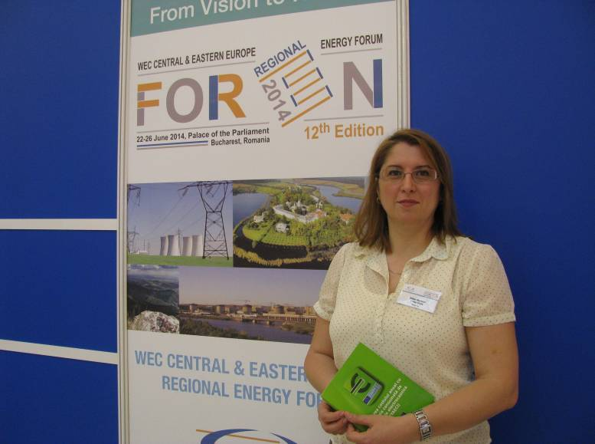

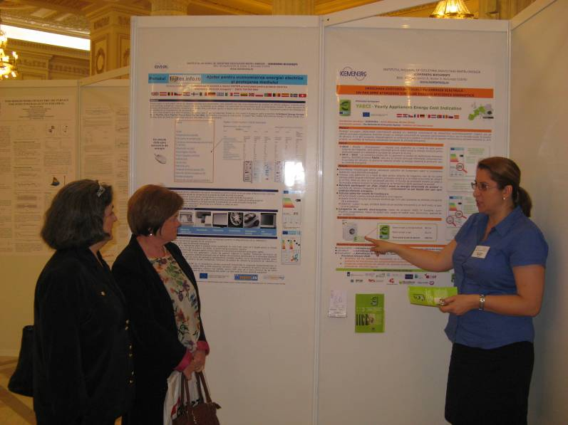

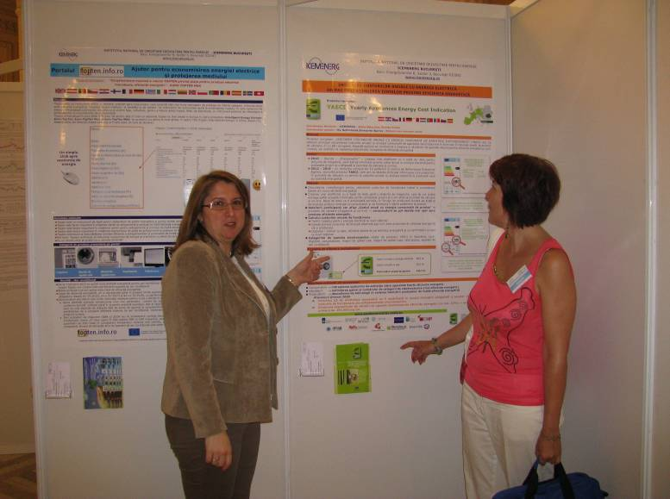

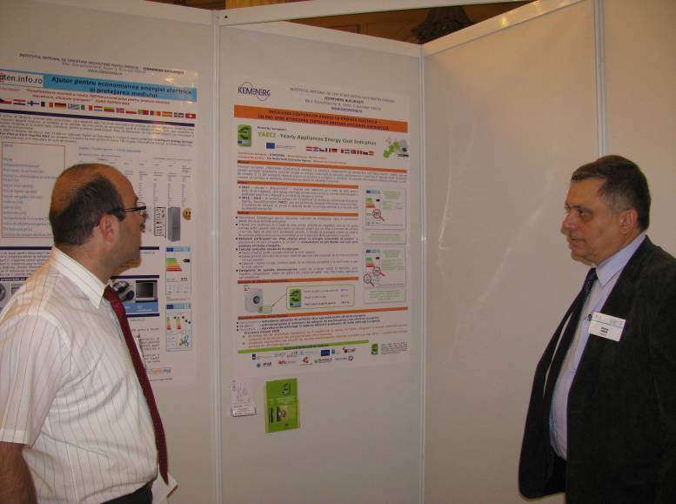

Bucharest, Romania, July 2014

